Action Line – New Features

- Modify the department on an Action Line Request: Users now have the ability to modify the department that is associated to an action line request within the “Action Line Request Manager” screen under the “Update Action Request” section. Users that have been assigned the Users will need to be assigned the proper role if they wish to maintain this field. Also, whenever the Department is modified this change is stored in the Request Activity Log.

- Modifications to Action Line Work Orders:
- The first modification is to the “Work Order Condensed” PDF printout and that now the last page was always an “end page” filled with lines for comments, a line for a signature, and a line for the date. This page used to always start on its own page even if there was room on the preceeding page. This has been modified so that the “comments, signature, and date” appears immediately after the last piece of data for the request.

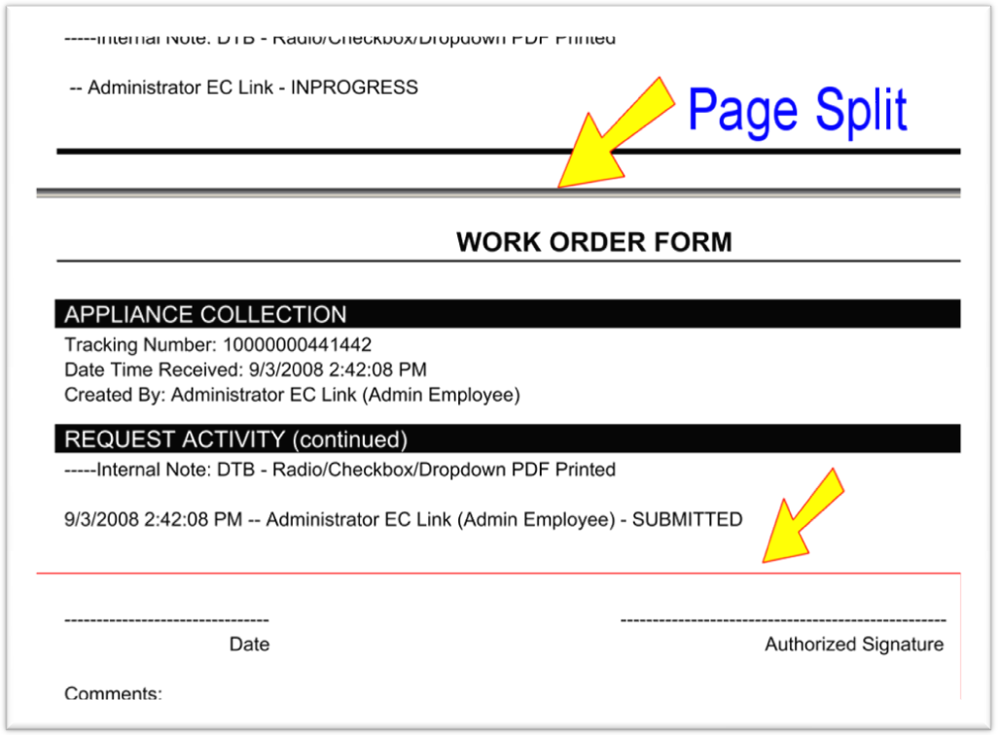
- The second change is on the “Action Line => Requests” screen and that users now have the ability to print multiple work orders. Use the checkboxes on the left to select the request(s) and then simply press the “Print Work Order(s)” button to print the selected requests out to the Work Order PDF.

- New searchable field now available on the “Action Line => Requests” screen:
The issue location’s “County” field can now be searched on if the organization has the feature to use this field. Admin users can now enter values to search for requests that have the value they have entered for this custom field.
*** NOTE: County is the default label for this field. This is a custom field that can be used for unique data stored related to the city. For example, some organizations call this field: wards, precincts, etc.

- Additional issue location fields are now being pulled during Action Line request creations: The “Listed Owner” and the “Legal Description” fields are now being populated at the time a request is submitted if values exist for a valid address selected (Address data is pulled from the “Citizen Registration => Valid Addresses” screen.)

